Project Design Document
1. Introduction
- Project Overview: A brief description of what the application does and its purpose.
- Objective: The primary goals, such as providing a reliable reservation management system for restaurants, handling user roles, and managing reservations and availability.
- Technology Choices: Explain why technologies like Spring Boot, React, and MySQL were chosen, emphasizing scalability, maintainability, and compatibility with the project's requirements and your current skill set.

2. Architectural Overview
- Layered Architecture: An overview of the layered structure (Presentation Layer, Business Layer, Persistence Layer, Database) and why this organization was selected.
- C4 Model Diagrams:
  - Level 1 (System Context): Illustrates how the system interacts with users and external systems. 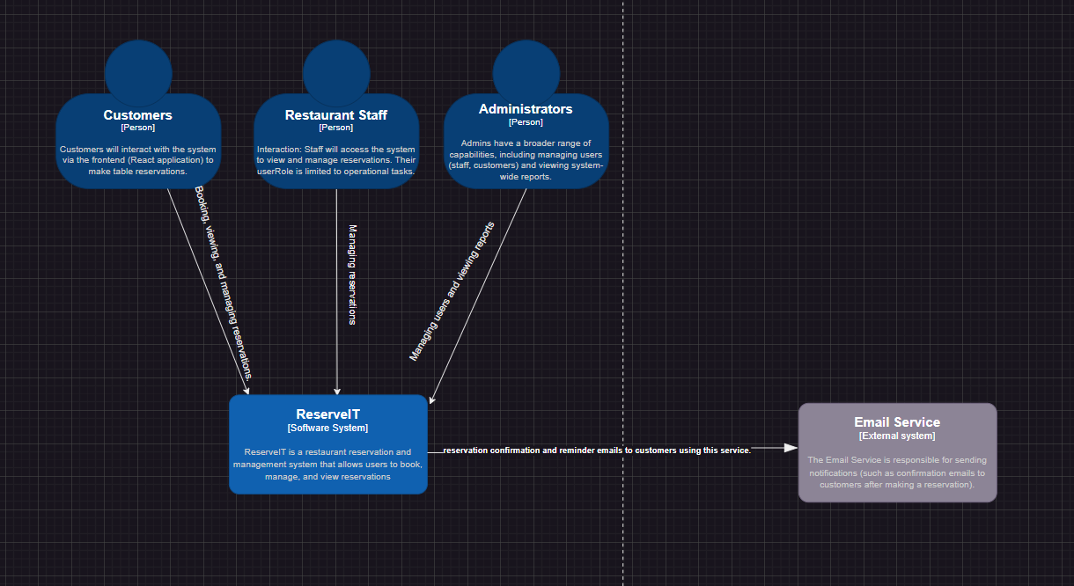
  - Level 2 (Container Diagram): Shows the major containers like Frontend, Backend, Database, and any external dependencies (like email services). 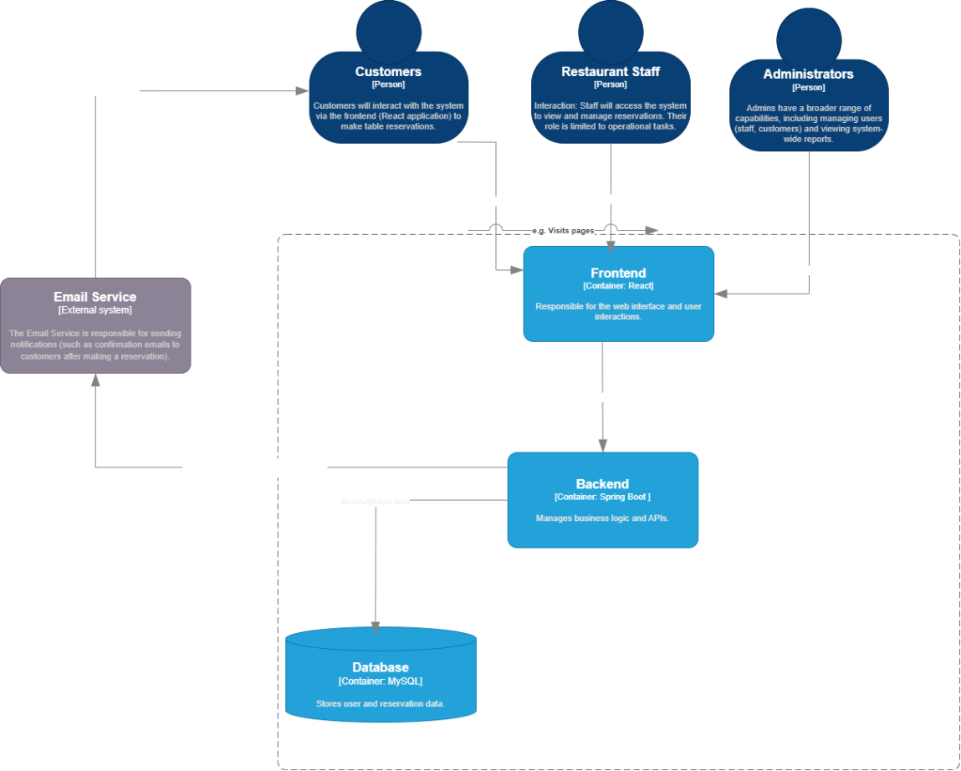
  - Level 3 (Component Diagram): Detailed view of the backend structure, showing key components like ReservationController, ReservationService, and ReservationRepository.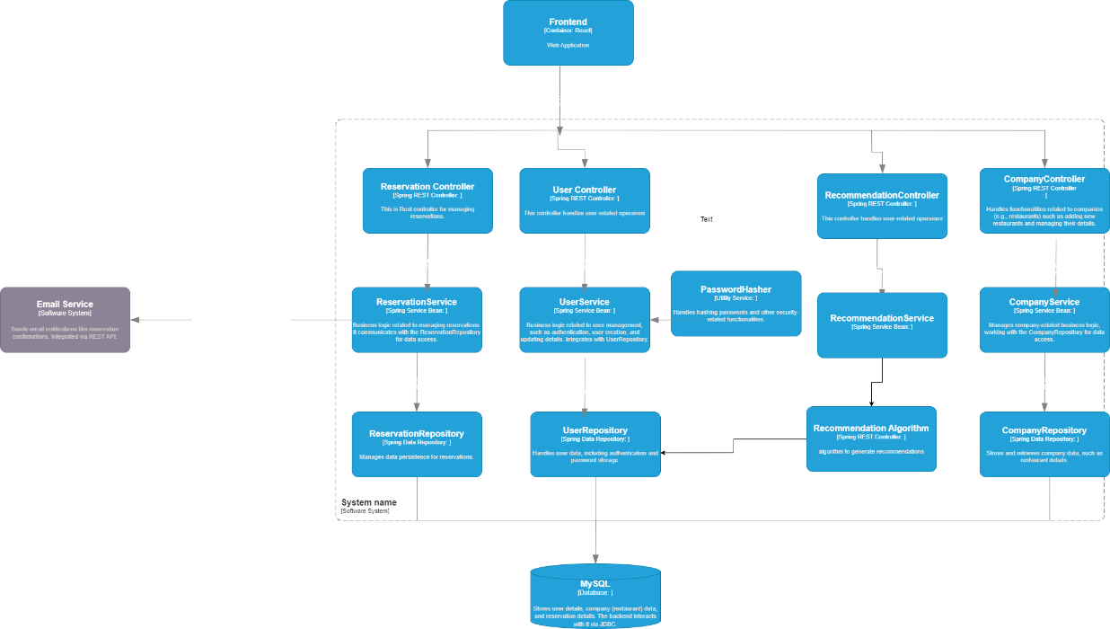
  - Level 4 (Class Diagram): Zooms into classes within a single component, such as the Reservation component, showing interactions among classes like ReservationServiceImpl, ReservationRepository, and DTOs.
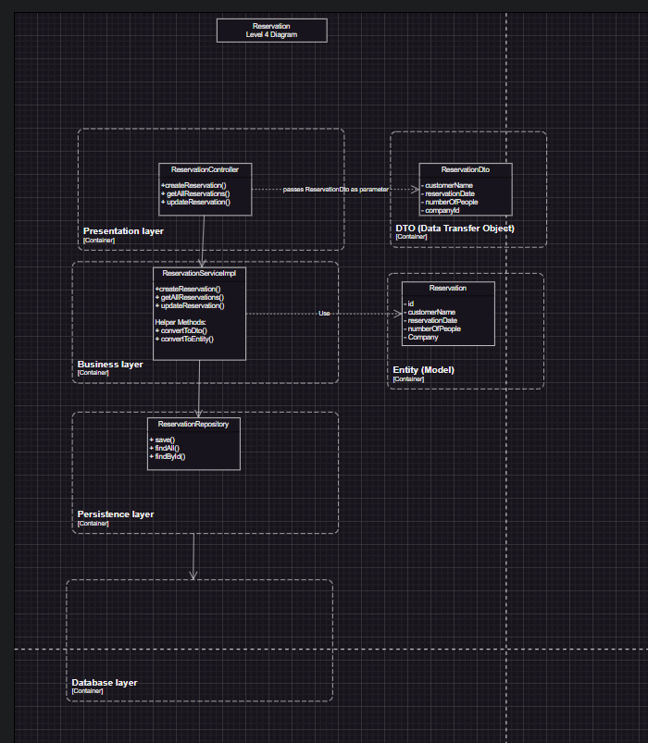

3. Technology Justifications
Spring Boot (Backend)
- Scalability: Spring Boot's efficient handling of RESTful APIs and support for microservices architecture.
- Community and Support: Large Java community and ample resources for troubleshooting and development support.
- Integration: Easy integration with MySQL for data storage, JWT for security, and validation libraries.
- Alignment with Skills: Familiarity with Java reduces the learning curve and ensures code efficiency.
React (Frontend)
- Component-based Architecture: Facilitates reusable and maintainable UI components, enhancing the speed and scalability of frontend development.
- Ecosystem and Tools: Access to React DevTools, a large library ecosystem, and ease of debugging make React an ideal choice for frontend development.
MySQL (Database)
- Reliability and Performance: Known for handling relational data well, robust, and commonly used with Spring Boot.
- Scalability: Can scale with the application as it grows, with support for cloud deployment.

4. CICD Pipeline Design
- Pipeline Stages: Explanation of each stage in the GitLab CI/CD pipeline:
  - Build: Compiles the application and prepares it for deployment.
  - Test: Runs unit tests to verify functionality.
  - Analyze: SonarQube analysis for code quality and potential issues.
- SonarQube Integration: Explanation of quality checks with SonarQube, allowing failures initially to improve over time.
- 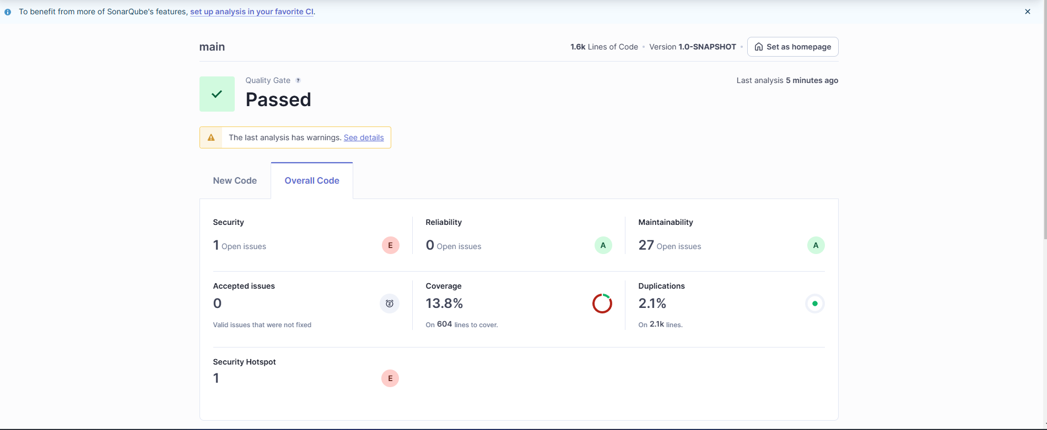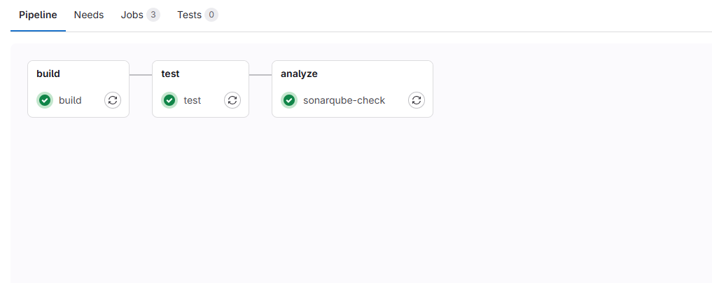

5. Database Migration with Flyway
- Purpose of Flyway: Ensures database versioning and schema management, helping track and apply schema changes across environments.
- Setup Details: How Flyway is configured in application.properties, including the location of migration scripts.
- Benefits: Simplifies collaboration, especially when schema changes are frequent, and ensures consistent database structure across development and production.

6. Testing Strategy
- Unit Tests: Testing each component in isolation, such as ReservationServiceTest for business logic.
- Integration Tests: Tests covering the interaction between layers, particularly focusing on the Persistence layer, using mocks for the database.
- Code Coverage: Explanation of JaCoCo integration, measuring the extent of testing coverage across the codebase.
7. Layered Architecture Explanation
The application follows a layered architecture pattern with these primary layers:
7.1 Presentation Layer
- Purpose: Handles user input and responses, managing HTTP requests.
- Components: Controllers that process incoming requests, call appropriate service methods, and return responses to the client.
- Example: ReservationController, UserController.
7.2 Business Layer
- Purpose: Contains core business logic, ensuring that rules and validation are applied to data processing.
- Components: Service implementations (e.g., ReservationServiceImpl, CompanyServiceImpl) that define the main logic for the application's operations.
- Example: ReservationServiceImpl.createReservation method applies business rules for creating a reservation.
7.3 Persistence Layer
- Purpose: Manages all interactions with the database.
- Components: Repositories that abstract the database access layer and provide methods to query and modify data in the database.
- Example: ReservationRepository, UserRepository.
7.4 Database Layer
- Purpose: Stores persistent data for the application, such as reservation records, user information, and company details.
- Example: MySQL database with tables for reservations, users, companies, etc.
8. Dependency Inversion Design
To enhance flexibility, the application uses the Dependency Inversion Principle. The controllers depend on service interfaces (ILogic) instead of concrete service implementations. The service layer, in turn, depends on repository interfaces (IDatabase) rather than specific JPA implementations. This allows for better testing and easier replacement or modification of dependencies.

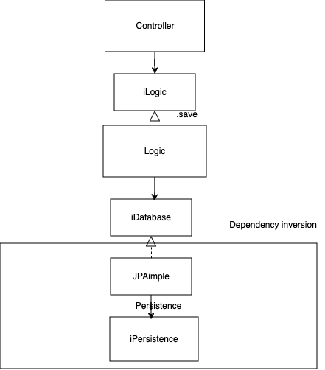

9. Design Decisions and Constraints
- Tooling and Software Choices: Reasoning behind selecting each technology and tool, including the benefits of each.
- Architectural Choices: Explanation of why a layered architecture was chosen, emphasizing separation of concerns, scalability, and maintainability.
- Constraints: Highlighting any limitations, such as dependency on MySQL, specific framework limitations, or the project's hosting environment.
10.SOLID Principles Implementation

Overview
This section explains how our restaurant reservation system implements the SOLID principles of object-oriented design, making the code more maintainable, flexible, and easier to understand.

Single Responsibility Principle (SRP)
"A class should have only one reason to change."

Implementation Examples:
1. Controller Classes
- `ReservationController`: Handles only HTTP requests/responses for reservations
- `UserController`: Manages only user-related endpoints
- Each controller focuses solely on routing and request handling

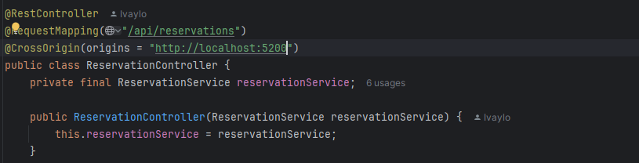
// only handles reservation-related endpoints

2. Service Classes
- `ReservationServiceImpl`: Contains only reservation business logic
- `CompanyServiceImpl`: Manages only company-related operations
- Each service class has a single area of responsibility

Open/Closed Principle (OCP)
"Software entities should be open for extension but closed for modification."

Implementation Examples:
1. User Roles System
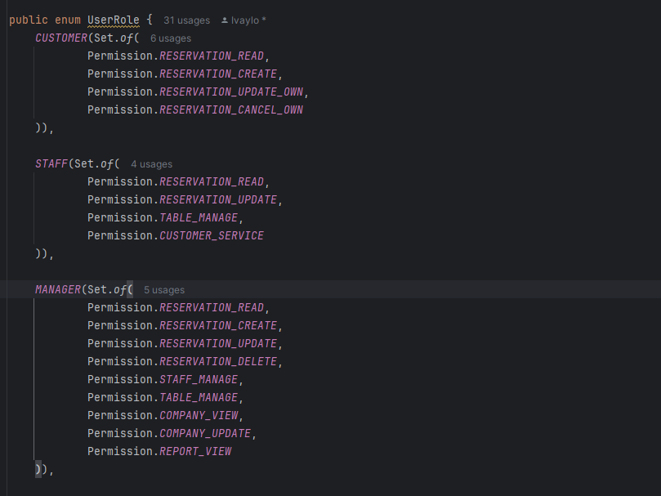
// New roles can be added without modifying existing code
2. Interface-based Design
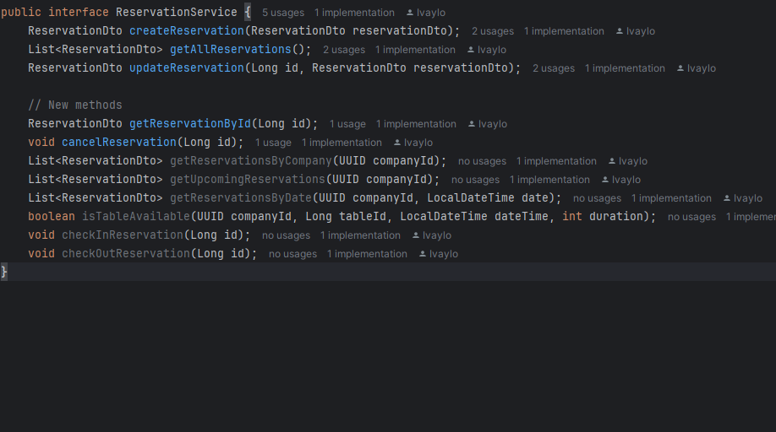
// New methods can be added in implementation without changing existing code
Liskov Substitution Principle (LSP)
"Derived classes must be substitutable for their base classes."

Implementation Examples:
1. User Class Hierarchy
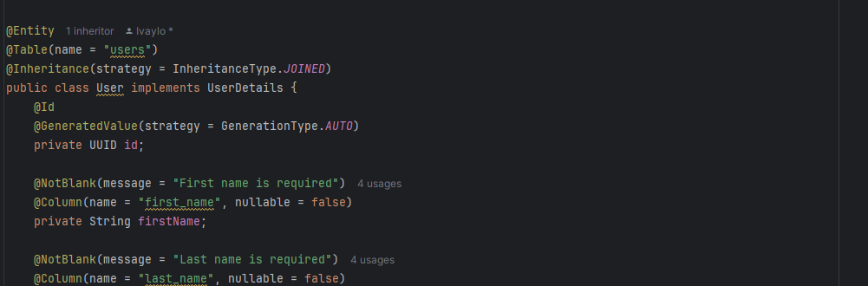
// Base user functionality
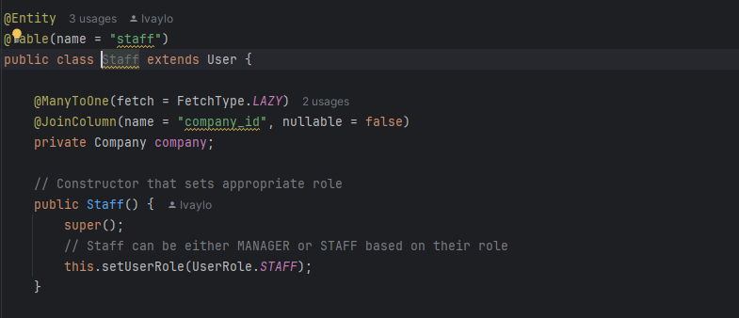
// Extends base user without breaking behavior
Interface Segregation Principle (ISP)
"Clients should not be forced to depend on interfaces they do not use."

Implementation Examples:
1. Database Interfaces
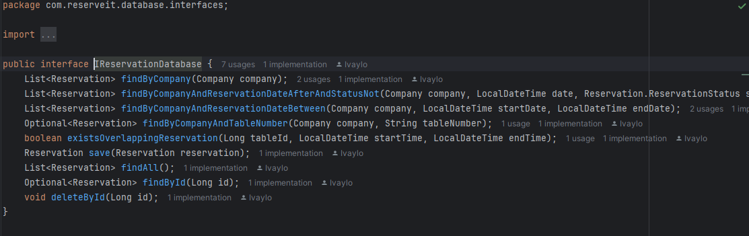
// Only reservations-specific methods

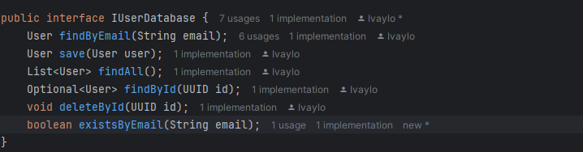
// Only user-specific methods
2. Service Interfaces
// Only reservation-related operations
Dependency Inversion Principle (DIP)
"High-level modules should not depend on low-level modules. Both should depend on abstractions."

Implementation Examples:

  - Service Layer Dependencies

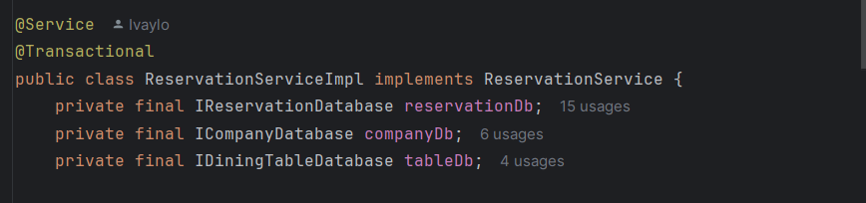
// Depends on interface, not concrete implementation

2. Controller Layer Dependencies
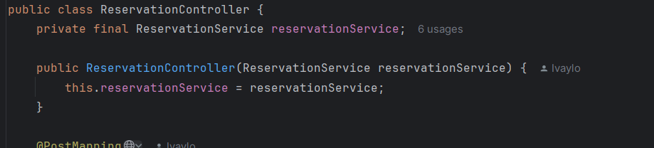
// Depends on service interface, not implementation

Benefits of SOLID Implementation
1. “Maintainability”: Each class has a clear, single purpose
2. “Flexibility”: New features can be added without modifying existing code
3. “Testability”: Classes with single responsibilities are easier to test
4. “Reusability”: Interface-based design allows for easy component reuse
5. “Scalability”: System can be extended without major refactoring

Real Application Examples
1. Adding New Features
- New reservation types can be added by extending existing interfaces
- New user roles can be added without modifying authentication logic

2. Testing
- Services can be tested in isolation due to interface-based design
- Mock implementations can be easily substituted for testing

3. Maintenance
- Bug fixes in one component don't affect others
- New business rules can be added without changing core functionality

11. CI Pipeline Architecture

11.1 Components Overview
1. Developer's Machine
- Local development environment
- Git repository
- Docker containers for local testing

2. GitLab Server
- Hosts repository
- Manages CI/CD pipeline
- Triggers builds on commits

3. Pipeline Runner
- Executes CI/CD jobs
- Runs in Docker containers
- Handles build, test, and analysis stages

4. SonarQube Instance
- Code quality analysis
- Test coverage reporting
- Security vulnerability scanning

11.2 Pipeline Flow
1. Development Stage
- Developer writes code locally
- Tests run in local environment
- Code committed and pushed to GitLab

2. Build Stage
- Gradle builds application
- Creates JAR file
- Runs unit tests

3. Test Stage
- Executes automated tests
- Generates test reports
- Validates application functionality

4. Analysis Stage
- SonarQube analyzes code
- Generates quality metrics
- Reports security issues

5. Docker Stage
- Builds Docker image
- Tags image with version
- Prepares for deployment

